MP Online Limited
Project Report
Digital Grievance Redressal System

Organization: Jawaharlal Institute of technology Borawan
Prepared By: Anjali Malviya
Date: May 2026
Digital Grievance Redressal System
1. Introduction
1.1 Purpose
The Digital Grievance Redressal System is a web-based application developed to provide a transparent and efficient platform for citizens to register complaints and track their resolution status. The system digitizes the complaint management process and improves communication between citizens and administrators.
1.2 Problem Statement
Traditional complaint management systems rely heavily on manual processes, resulting in delays, lack of transparency, and inefficient tracking of complaints. Citizens often face difficulties in knowing the progress of their submitted complaints. The proposed system provides a centralized digital solution to address these issues.
1.3 Objectives
- Provide an online platform for complaint registration.
- Enable users to track complaint status.
- Allow administrators to manage complaints efficiently.
- Support image uploads as evidence.
- Improve transparency and accountability.
- Maintain digital records of all complaints.

2. Technology Stack
Layer | Technology | Purpose
Frontend | React JS | User Interface Development
Styling | Tailwind CSS | Responsive and Modern UI Design
Routing | React Router DOM | Navigation Between Pages
Backend | Node.js & Express.js | Scalable REST API Development and Middleware Routing
Database | MongoDB | NoSQL Document Database for flexible grievance data storage
Authentication | JWT | Secure Login and Authorization
Password Security | bcrypt | Password Encryption
API Communication | Fetch API | Frontend-Backend Communication
Version Control | Git & GitHub | Source Code Management
IDE | Visual Studio Code | Development Environment

3. System Architecture
The system follows a three-tier architecture:
Presentation Layer
- React JS
- Tailwind CSS

Application Layer
- REST Api
- JWT Authentication
Data Layer
- Database
MongoDB Data Flow
User → React (Frontend UI)
↓
FastAPI (Backend API Layer)
↓
MongoDBDatabase (Storage Layer)

4. Database Design
4.1 Users Collection

Field Name | Type | Description
_id | Integer (Primary Key) | Unique user identifier
name | String | User full name
email | String | User email
password | String | Encrypted password
Role | String | User role

4.2 Complaints Collection

Field | Type
id | Integer
title | String
category | String
description | Text
user_id | Integer (Foreign Key)
status | String
admin_remark | String
created_at | DateTime
updated_at | DateTime

5. Features Implemented
User Features
- User Registration
- Secure Login using JWT
- Multi-step Complaint Submission Form
- Complaint Categorization
- Complaint Status Tracking
- Responsive User Dashboard

Admin Features
- View All Complaints
- Update Complaint Status
- Manage User Complaints
- Add Administrative Remarks
- Complaint Monitoring Dashboard

6. Complaint Categories
- Water Supply
- Electricity
- Gas Leakage
- Drainage / Sewage
- Road Damage / Potholes
- Street Lighting
- Traffic Signal Issue
- Public Transport Issue
- Garbage Collection
- Public Toilet Issue
- Sanitation Problem
- Park Maintenance
- Encroachment
- Other

7. Security Features
- JWT Based Authentication
- Password Hashing using bcrypt
- Protected API Routes
- Role-Based Access Control

9. Challenges Faced
Technical Feature | Implementation Details
JWT Authentication | Implemented proper token validation for secure user sessions.
File Upload Handling | Used FormData and Multipart support via Express middleware.
Frontend-Backend Communication | Configured CORS Middleware for secure cross-origin API requests.
Complaint Image Preview | Implemented React components for instant client-side image preview.
MongoDB Data Management | Structured NoSQL collections and developed backend CRUD APIs using Mongoose.

11. Snapshots

1. RegisterPage:-
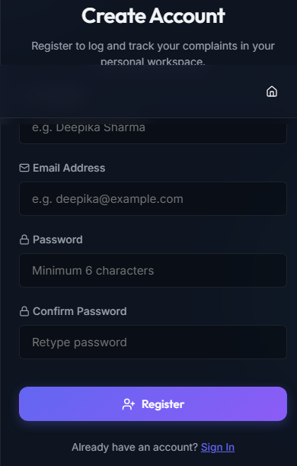

2. LoginPage:-
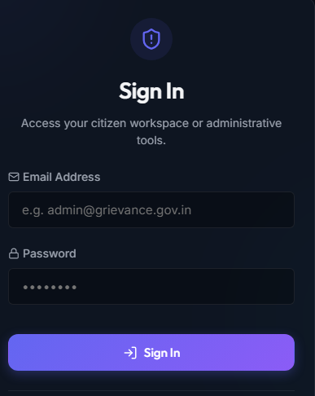

3.Home Page:-
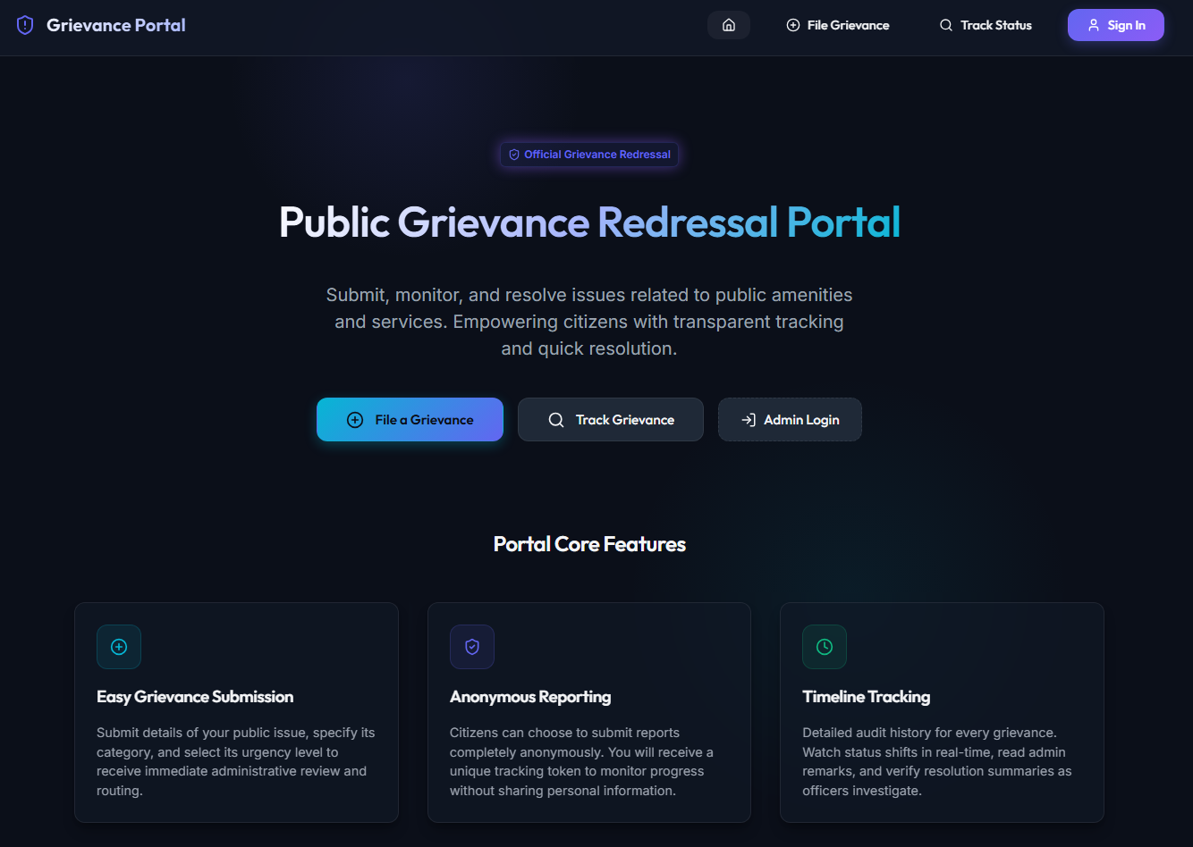

4. MyComplaint:-
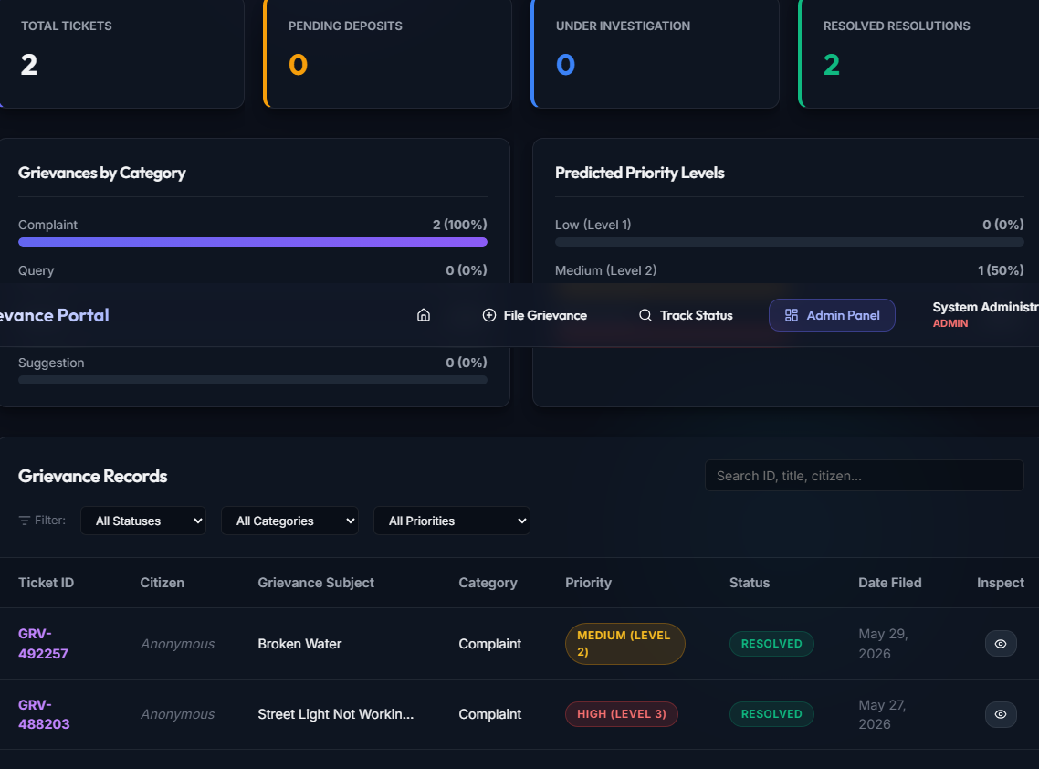

5. Track Ticket Status :-
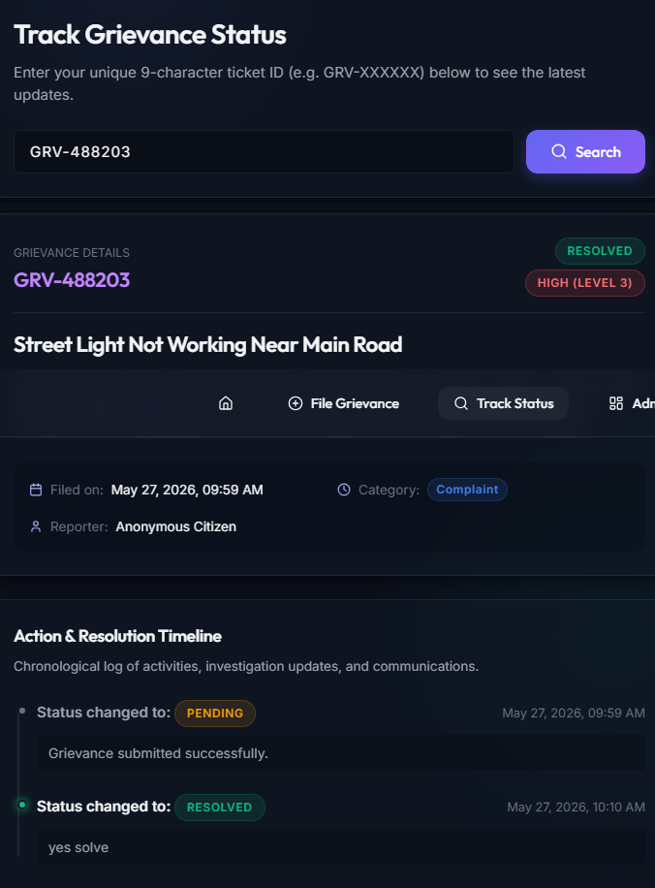

6. Admin Dashboard :-
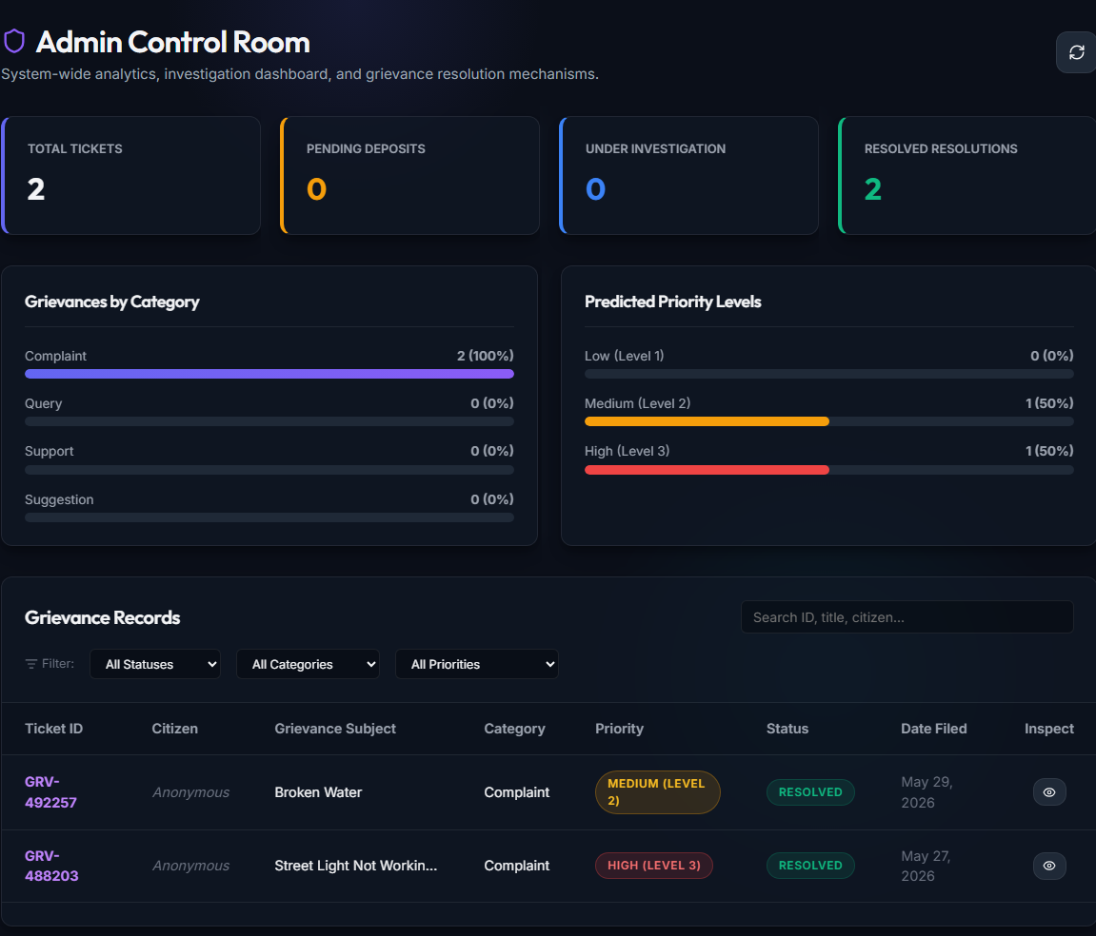

10. Conclusion
The Digital Grievance Redressal System successfully provides a digital platform for registering and managing public complaints. The application improves transparency, accountability, and efficiency by enabling users to submit complaints online and monitor their status. The integration of React, Express.js, Node.js, MongoDB, and JWT ensures a secure, scalable, and user-friendly solution.

11. Future Scope
- Email Notifications
- SMS Alerts
- Mobile Application
- AI-based Complaint Categorization
- Multi-language Support
- Advanced Analytics Dashboard
- Complaint Priority Prediction
- Geo-location Based Complaint Tracking

